CHAPTER 6
APPENDICES

6.1 Information about taxes

INFORMATION ON TAXES - CONTENTS

6.1.1 Application for Corporate Tax Debit Card (Activated from 2020)
6.1.2 Tax E-filing (Activated from October 2020)
6.1.3 Tax registration
6.1.4 MPU member banks
6.1.5 Personal income tax of each employee
6.1.6 Application for Business Taxpayer Registration for Company
6.1.7 Monthly settlement of personal income tax for individuals
6.1.8 Annual settlement of personal income tax for individuals
6.1.9 Application for Certificate of Commercial Tax for both corporate and individual
6.1.10 Offsetting CT/submission of Quarterly Commercial Tax Return
6.1.11 Stamp duty
6.1.12 Definitions
6.1.13 List of forms

6.1.1 Application for Corporate Tax Debit Card
(LTO activated before October 2020)

Internal Revenue Department no longer issues “identification numbers for tax payments” separately, and instead has changed the tax IDs since October 1, 2020, as follows:
-- For paying personal income tax, the National Registration Card Number of the person concerned or the employee concerned has become the Personal Income Tax ID No.
-- For paying all business-related taxes, Company Registration Number has become the Corporate Tax ID No. (TIN No.)

Online payment of taxes
All companies in Yangon will have to file and pay their taxes—income tax, commercial tax, special goods tax or capital gain tax—online, starting from October 1, 2020. Tax-payers can pay their taxes via their internet banking, mobile banking apps and corporate debit cards issued by the Myanmar Payment Union (MPU). Payment of Employee Personal Income Tax (PAYE) at the Tax Office using passbooks must be changed to electronic payment system via a mobile application which can be download from Play Store. Personal Income Tax ID is National Registration Card Number.
Conditions on the use of card
It is needed to pay tax online one day before the due date. The tax paid online thus will enter the MEB account of the Tax Office the following day.
1 Tax-payers must apply for Corporate Debit Card at an MPU bank together with the evidence of IRD.
2 The Corporate Debit Card can be used only for paying taxes. If the card-holder wants to use it also for other purposes, he must apply to the bank.
3 The maximum amount of tax that can be paid at one time (at one transaction) is MMK 5 million. If the amount exceeds one-day accumulative total of MMK 5 million, it has to be transferred more than one time.
4 MMK 2,000 will be charged for one transaction as E-commerce Transaction Charge.
5 One Time Password (OTP) must be used for each transaction for security. The tax-payer must provide a dedicated e-mail account to the bank, where the card is applied for, for sending each OTP.
6 If the transaction is successful, e-mail will be sent to the tax-payer informing him that the transaction is successful. If he does not receive an e-mail, the transaction is not successful.

Procedure for applying for CTDC
The Corporate Tax Debit Card (CTDC) can be used for paying Income Tax, Capital Gains, Commercial Tax, and Specific Goods Tax via e-commerce online. The CTDC is linked to corporate customers’ banking accounts and carries the Company Name on the card. For the time being Stamp Duty has to be paid at the Township IRD office concerned.

Requirements for applying for CTDC and facts about CTDC
Application form
Only Company Name printed on the card
Restricted by MCC (Government Payment)
Only online transactions are allowed
Company Current Account required
Only Single Card will be issued
Email address required
Card Statement provided
Fees MMK
Issuance Fee Waived
Annual Fee 3,000 (First Year Waived)
Replacement Fee 3,000
Transaction Fee 2,000
Card loss/stolen 3,000
Transaction Amount Limit Unlimited
Required documents
1 Application for MPU Corporate Tax Debit Card
2 Board of Directors Meeting Minutes or Company Resolution
3 MPU Corporate Tax Debit Card Terms and Conditions
4 Company Registration Certificate
Documents that can be downloaded
1 Approved MPU Corporate Tax Debit Card form
2 Approved Sample Company Resolution – MPU Corporate Tax Debit Card
3 Latest MPU Corporate Tax Debit Card Terms and Conditions
Call for seeking advice:
(+95) 1 370138 ~ 39. (+95) 1 370320

Online tax payment procedure
Step 1: Visit www.irdmyanmar.gov.mm / https://onlinepayment.ird.gov.mm/etax
Step 2: Check the data and press “Confirm.”
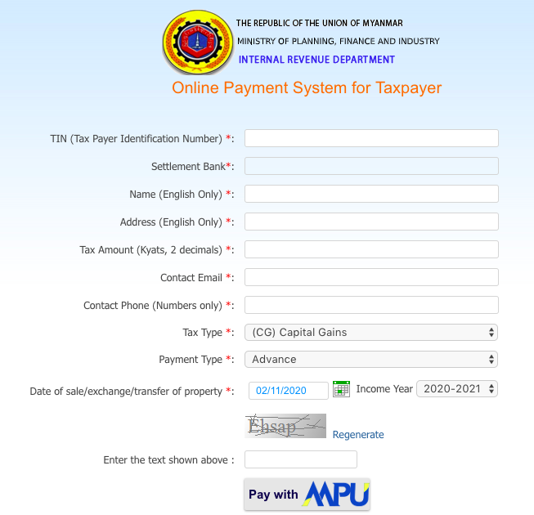

√ Agree to pay transaction fee for tax payment.

CANCEL CONFIRM u

Step 3: MPU page appears, fill in card information, obtain OTP and proceed with making the payment.

Payment acceptance and authentication
Merchant name :
F:\Requirement_Document_For_Tax_Payer\eTax_payment_ flow_Page_4.jpg

Card Number :

Expire Date : 11 q 2015 q

GET OTP OTP will be sent to your e-mail.

OTP : 123456

CANCEL CONFIRM PAYMENT u

OTP: One Time Password

Step 4: Re-check the data before approving of your tax payment.

Payment result

Merchant Name: ETAX Service
Product Description: Tax Payment
Invoice Number: IRD1915050718344
Amount: 501,000 MMK

Card Number: 9503-30XX-XXXX-0536
Status: √ Approve
Approve Code: 189506
Date/Time: 03 Jul 2015
Transaction Ref: 54734

CONTINUE u

Step 5: If the payment is successful, the following page will appear.

Payment Result for Large Taxpayers’ Office
Your payment is successful. The receipt will be sent to your email.

Payment Reference : IRD1915050718344
Total Amount (Kyats) : 501,000
Payment Date/Time : 03/07/2015 17:20:25
Approval Code : 189506
Card No : 9503-30XX-XXXX-0536

Pay Another Tax Go Back To Home

Step 6: IRD Web Portal will send you auto-generated e-mail of your payment for your record.

alert@irdmyanmar.gov.mm alert@irdmyanmar.gov.mm via 2c2p.com
to me q

www.irdmyanmar.gov.mm

Dear AA Company

Thank you for paying tax. You have paid 500,000 kyats to IRD successfully.

Here are the details of your payment transaction.
Your Tax Reference: IRD1915050718344
Payment Date/Time: 03/07/2015 17:20:25
Tax Amount: 500,000 Ks.
Fees: 1,000 Ks.
Total Amount: 501,000 Ks.
Card Number: 9503-30XX-XXXX-0536

Sincerely,
Large Taxpayers’ Office

Actins to be taken if errors occur after paying tax by MPU Card
1 If taxpayers have found out errors in tax-payment data, within the month concerned, after paying tax online, such as Tax Type, Payment Type, Tax Period and Income Year, they can apply to the Tax Office concerned for amendment of error(s) before the end of the month.
2 If taxpayers have found out the error of having paid the tax to a wrong Tax Office, they must inform the Tax Office concerned within the day, and apply for “Dispute” to the Bank to which they paid the tax.
3 If the application for amendment of error(s) is beyond the period concerned, the tax paid will be refunded in accordance with the existing procedures on taxes and accounts or the tax paid will be subtracted by advance money under the title concerned.

“Don’ts” for taxpayers online by using MPU Card
(a) Incorrectly choosing the Type of Tax to be paid
(b) Incorrectly choosing the Type of Tax Payment
(c) Not properly choosing the Tax Payment Period
(d) Paying tax collectively for a number of fiscal years without paying tax in the tax period for each fiscal year
(e) Paying tax collectively for different types of tax in one single transaction
(f) Lack of schedule for salary income tax and matters of subtracting from the principal

6.1.2 Tax e-Filing
(Activated from October 2020)

Requirements for using e-Filing Management System
1 First, the taxpayer has to register an Account.
2 Online declaration can be filed only after the Account Registration has been approved by IRD.
2
Process
1 Visit IRD website https://www.ird.mm .
2 Click on “E-Filing Service Login Here>>”.
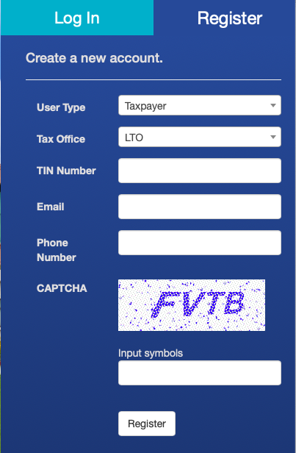
3 Click on “Register” tag and fill up the required information, and click on the “Register” button.
4 Check the completion statement whether it is showing “Registration has completed” or not.

Registration has finished!

We will inform to you whether you can access your account.

BACK TO LOGIN
3

https://efiling.ird.gov.mm/

4

5 IRD will send the “Confirm” email to you. Check the “Confirm” email in your mail box.
6 Log in to IRD site via email.
7 Fill up your full name, contact email, create password, contact phone No.
8 After filling the requirements, click “Confirm Email” button.
9 Then, you can log in to your account to do e-filing.
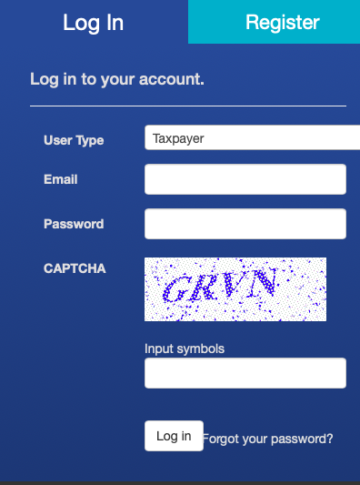

Email confirmation
_______________________

Thank you for confirming your email.

Full name

Email

Password

Confirm
password

Phone Number

Confirm Email
8
7

9

TAX CALENDAR
Taxpayer’s task | Period in which the task is to be executed
Paying monthly  Special Goods Tax | Within 10 days from the end of the month concerned
Paying monthly  Commercial Tax | Within 10 days from the end of the month concerned
Paying quarterly  Income Tax | Within 10 days from the end of the quarter concerned
Filing quarterly Special Goods Tax Return | Within 10 days from the end of the quarter concerned
Filing quarterly Commercial Tax  Return | Within 1 month from the end of the quarter concerned
Filing yearly Commercial Tax  Return | Within 3 months from the end of the fiscal year concerned
Filing Annual Income Return | Within 3 months from the end of the income year concerned

6.1.3 Tax registration
1 Payment of taxes: TIN (Taxpayer Identification No), that the Investor has obtained from completing company registration, can be used for paying any tax, that includes, but not limited to, corporate tax (after the tax exemption period is over), commercial tax, withholding tax, capital gain tax, special goods tax and personal income tax.
2 Opening account: The investor needs to open an account with an MPU-member bank to pay online. https://onlinepayment.ird.gov.mm/etax (Online Payment System for Taxpayers, Internal Revenue Department)
3 Personal income tax: Each company deducts personal income tax from each employee’s salary and pays through the Front Office to KESC. The progressive rate system is applied for PIT and the rates are mentioned in this Appendix.
4 Exemption from commercial tax: The free-zone investors are exempted from the commercial tax, however non-free-zone investors are exempted from the commercial tax for five years from the date they commenced their commercial operations. Hence, non-free-zone investors need to pay commercial tax for land lease.
5 Import duties: The import duties (that include commercial tax) for the importation of duty-free products (such as machinery, equipment, construction material, etc.) are exempted for both free zone and non-free investors. However, import duties for the importation of raw materials are exempted for free zone investors but not for non-free zone investors. The detailed explanation table regarding what types of tax are exempted or not exempted for the developer or free zone investor or non-free zone investor can be downloaded from the KMIC website.
6 Commercial tax: The investor must pay the commercial tax every month, within 10 days from the end of the month concerned. The stamp duty is to be paid before and on the date of signing a contract or an agreement. The commercial duty is mandatory and late payment is subject to a fine. If failure to pay Stamp Duty is discovered by the tax auditor, a fine—three times the duty—must be paid, even if any court case has not occurred from this failure. A contract or an agreement without a stamp duty and being registered is not valid at a Myanmar court.
7 Arbitration: An investor can have any country of his choice in the event of arbitration (according to the Myanmar Special Economic Zone Law), and this should be clearly provided in the contract. Otherwise, arbitration shall be in Myanmar in compliance with the Myanmar law.

6.1.4 MPU member banks
In July 2015, MPU was transformed into a public company and now has 29 member banks. Of the 29 banks, 21 have issued debit cards and are equipped with ATMs and POS machines. The following are some of its members:
1 | Asia Green Development Bank | AGD Bank
2 | Ayeyarwaddy Bank | Aya Bank
3 | Cooperatives Bank | CB Bank
4 | Construction, Housing and Infrastructure Development Bank | CHID Bank
5 | First Privat Bank | —
6 | Global Treasure Bank | GTB
7 | Innwa Bank Limted | IBL
8 | Kanbawza Bank | KBZ
9 | Myanmar Apex Bank | MAB
10 | Myanmar Citizens Bank | MCB
11 | Myanma Economic Bank | MEB
12 | Myanma Foreign Trade Bank | MFTB
13 | Myanmar Investment and Commercial Bank | MICB
14 | Myanmar Microfinance Bank | MMB
15 | Myanmar Oriental Bank | MOB
16 | Myawaddy Bank Limited | MWD
17 | Rural Development Bank | RDB
18 | Shwe Bank | SB
19 | Small and Medium Industrial Development Bank | SMIDB
20 | Tun Commercial Bank | TCB
21 | United Amara Bank | UAB
22 | Yangon City Bank | —
23 | Yoma Bank | —

6.1.5 Personal income tax of each employee
Documents needed:
 | 1 | Report on Recruitment Status
 | 2 | Employment Contract
Procedure:
 | 1 | The Investor shall submit a list of employees with the Form of Recruitment Status, and with the standard Employment Contract it uses, to IRD.
Note:
 | The investor can use the National Registration Card No. of each of his employees as the General Index Registration Number. NRC No has become the Tax ID No for individuals since October 1, 2020.

6.1.6 Application for Business Taxpayer Registration for Company
Documents needed:
 | 1 | Basic Taxpayer Registration Form
 | 2 | Large Taxpayer Office (LTO) Information Gathering Worksheet
 | 3 | Current Bank Account Number
 | 4 | Letter of Confirmation for Appointment, if the applicant is an agent
 | 5 | Bank Statement which includes transaction records for one year if the applicant has more than two bank accounts.
Procedure:
 | 1 | The applicant submits the necessary documents to LTO or online.
 | 2 | IRD reviews the application documents by referring to the following documents:
 |  | a | Certificate of Incorporation
 |  | b | Investment Permit
 |  | c | Company extract
Note:
 | The investor can use the Company Registration No. as the TIN No.

6.1.7 Monthly settlement of personal income tax for individuals
Documents needed:
 | 1 | List of income tax deducted monthly
 | 2 | Monthly Income Tax Calculation Sheet
 | 3 | For new taxpayers of Income Tax:
 |  | a | Copy of National Registration Card (NRC)
 |  | b | Evidence of receiving the exemption under Section (a) of Income Tax Law, such as:
 |  |  | – | Household Certificate (original / copy)
 |  |  | – | Birth Certificate (original / copy)
 |  |  | – | Deed of Marriage (copy)
Note:
 | From the month that follows, the Investor shall submit the copy of Bill of Salary Payments of the Employees to IRD and pay the personal income tax—withheld by the Investor—within 15 days from the day of paying salaries.
 | Any person with an annual income of more than MMK 4,800,000 shall pay income tax.
 | From October 1, 2020, personal income tax (PAYE) is to be paid online. It is needed to fill up and submit the Excel file (template), provided online by IRD.

6.1.8 Annual settlement of personal income tax for individuals

Documents needed:
 | 1 | Annual Return Form (Wa Nga – 16)
 | 2 | Individual Tax Calculation Sheet
Procedure:
 | 1 | The applicant submits necessary documents to IRD office concerned within 3 months after the end of fiscal year concerned.
 | 2 | If there is deficit of payment, the Investor shall make payment for the deficit. Overpayment occurs when an employee has resigned or an expatriate employee has gone back to his country. In that case, the overpaid tax will be refunded or carried forward to the next year.
Note:
 | The Return of Annual Income Tax shall be submitted to LTO or MTO concerned within 3 months after the end of fiscal year.

6.1.9 Application for Certificate of Commercial Tax for both corporate and individual

Documents needed:
 | 1 | Commercial Tax Registration
 | 2 | Commercial Tax Information Commencing of Business
 | 3 | Previously issued Certificate of Commercial Tax Registration of the Company or Individual (if any)
 | 4 | Two passport size photos of Managing Director
 | 5 | Company extract
 | 6 | Company Registration Certificate
 | 7 | Form 1 (Ka Tha Kha – 1)
 | 8 | Form 2 (Ka Tha Kha – 2)
 | 9 | Form 3 (Ka Tha Kha – 3) (If renewal of CT)
 | 10 | IRD reviews the application documents by referring to the following documents:
 |  | a | Certificate of Incorporation
 |  | b | Investment Permit
Procedure:
 | 1 | The applicant submits the necessary documents to IRD.
 | 2 | IRD reviews the submitted documents and provides Certificate for Commercial Tax for both Company and Individual
Remark:
 | It is necessary to renew the Certificate of Commercial Tax for Company every year. (Submission deadline is one month before year end.)

6.1.10 Offsetting Commercial Tax / submission of Quarterly Commercial Tax Return

Documents needed:
 | 1 | Quarterly Commercial Tax Return
 | 2 | In order to offset, if it is importation:
 |  | a |  | Import Declaration (ID) Form (original/copy)
 |  | b |  | Clearance Certificate which is prepared for Importing (Form 32 – Ka Tha Kha 32)
 |  | c |  | Explanatory Note for Offsetting
 |  | d |  | Certificate of Commercial Tax Registration of the Company or Individual
 | 3 | In order to offset, if it is local sale, domestic production, trading, rendering services,
 |  | a | Clearance Certificate which is prepared for Local Purchase & Service (Form 31 – Ka Tha Kha 31)
 |  | b | Explanatory Note for Offsetting
 |  | c | Certificate of Commercial Tax Registration of the Company or Individual
Procedure:
 | 1 | The applicant submits the necessary documents to the IRD.
 | 2 | IRD reviews the submitted documents and provides the Informing Letter for receiving of the Return.
According to Commercial Tax Regulation Section 42:
– The taxpayer may be able to claim a credit for commercial tax paid at the time of importation, purchasing, trading and services providing.
– Regarding exports, the commercial tax paid at the time of purchase or production of the goods may be offset from the commercial tax due on the export according to the regulations. Notwithstanding the commercial tax regulations, if the commercial tax due on the export is less than the commercial tax paid at the time of purchase or production of the goods, a refund may be demanded. This does not apply to goods which are bought in the country and brought overseas for personal use.

6.1.11 Stamp duty

Documents needed:
 | 1 | Any relevant contracts, such as:
 |  | a | Land Lease Contract
 |  | b | Memorandum of Association and Articles of Association
 |  | c | Joint Venture Agreement
 |  | d | Production Contract
 |  | e | Profit Sharing Contract
 |  | f | Conveyance
 |  | g | Lease and Sub-lease Agreement
 |  | h | Fire Guarantee Deposit
 |  | i | Transfer of Shares
 |  | j | Any receipt on which the amount is shown as more than MMK 5,000 (e.g. personal income tax payment receipt)
 |  | k | Construction Agreement/Contract
 |  | l | Granted for fine, premium or for money advanced
 |  | m | Mortgage
Procedure:
 | 1 | The applicant submits necessary documents to IRD.
 | 2 | IRD checks the submitted documents and calculates the fee of stamp duty.
 | 3 | IRD informs the fee of stamp duty to the applicant. (Provide 3 copies of challan to the applicant)
 | 4 | The applicant makes payment to MEB bank and the bank keeps 1 copy of the challan.
 | 5 | After payment has been made, IRD provides stamps on the documents and receipt to the applicant. (IRD keeps one copy of the challan and issues another one copy to the applicant.)
Application fees: |  |  |  | MMK
 | 1 | MOA and AOA |  | 165,000
 | 2 | Joint venture agreement |  | 1% (max duty 150,000)
 | 3 | Production Contract |  | 1% (max duty 150,000)
 | 4 | Profit Sharing Contract |  | 1% (max duty 150,000)
 | 5 | Construction Agreement |  | 1% (max duty 150,000)
 | 6 | Conveyance |  | 2%
 | 7 | Lease & Sub-Lease Agreement |  | 0.5% (for < 3 years)
 | 8 | Lease & Sub-Lease Agreement |  | 2% (for > 3 years & annual average of lease term)
 | 9 | Granted for a fine or premium or for money advanced: |  | 2%
 | 10 | Transfer of shares |  | 0.1%
 | 11 | Mortgage |  | 2%
 |  | (When possession of the property or any part of the property comprised in such deed is given by the mortgagor or agree to be given) & 0.5% (When possession is not given or agreed to be given as aforesaid)
 | 12 | Fire Guarantee Deposit: |  | 2%
Remarks:
Stamp duties are taxed on instruments and not on transactions or persons. Any contract or instrument that are not made of affixing Stamp Duty will not be executed by the court in Myanmar. If any resolution dispute is intended to be taken to court in Myanmar, contract must be affixed with stamp duty. Where a contract or instrument is not duly stamped by the time of agreement is signed, there shall be imposed a surcharge of three times amount of the duty.
For land lease contract:
– Stamp duty for land lease contract shall be paid by the leaser (herein Investor)
– Long-term lease contract shall be duly stamped for legality and validity.

6.1.12 Definitions
1 Income year and assessment year
Income year: October 1 of a year to September 30 of the following year. First income year starts from the date of company registration.
Assessment year: October 1 of the following year to September 30 of the following year + 1.
Self-Assessment System is now being developed.
2 Tax holiday period
5 years = 60 months from the date of commencement of operation
7 years = 84 months from the date of commencement of operation
3 Refund of Commercial Tax
The Customs collects the duty and commercial tax upon the import. Commercial Tax is collected by the Customs on behalf of Internal Revenue Department.
For “Draw Back” which may be requested in case of the export of goods which are made of the materials imported with payment of above taxes, the Customs will be responsible for confirming the amount of refund.
4 Tax Return
“Tax Return” of a company has to be made by the end of December of the following year
“Annual Return” within 3 months after the end of the financial year.
Time specifications for submission of tax return and advance payment of tax
Subject |  |  | Time for submission of tax return
Submission of Commercial Tax Return:
 |  | Qtr 1: Oct 1 – Dec 31 | To submit before Jan 31
 |  | Qtr 2: Jan 1 – Mar 31 | To submit before Apr 30
 |  | Qtr 3: Apr 1 – Jun 30 | To submit before Jul 31
 |  | Qtr 4: Jul 1 – Sep 30 | To submit before Oct 31
Annual Return: |  |  | To submit within 3 months from the end of the financial year concerned.
Submission of Income Tax Return |  |  | To submit within 3 months of the end of the financial year concerned (Oct-Nov-Dec)
Submission of Capital Gain Return |  |  | Within 30 days after the date of selling, exchanging and others of capital asset (or)
 |  |  | To submit within 3 months of the end of the financial year concerned (Oct-Nov-Dec)
Subject |  |  | Time when advance payment of tax shall be paid
Advance payment of commercial tax |  |  | Within 10 days after the end of month (monthly)
Advance payment of tax for Capital Gain |  |  | Within 30 days after the date of selling, exchanging and others of capital asset (or)
 |  |  | To submit within 3 months of the end of regarding financial year (Oct-Nov-Dec)
Advance payment of quarterly income tax
 | Qtr 1: Oct 1 – Dec 31 |  | Within 10 days after the end of Dec
 | Qtr 2: Jan 1 – Mar 31 |  | Within 10 days after the end of Mar
 | Qtr 3: Apr 1 – Jun 30 |  | Within 10 days after the end of Jun
 | Qtr 4: Jul 1 – Sep 30 |  | Within 10 days after the end of Sep

6.1.13 List of forms
Form IRD 1-1: Business Taxpayer Registration Form
Form IRD 1-2: Large Taxpayer Office (LTO) Information Gathering Worksheet
Form IRD 2-1: Commercial Tax Registration
Form IRD 2-2: Commercial Tax Informing Commencing of Business
Form IRD 2-3: Sample of Certificate of Commercial Tax Registration of the Company or Individual
Form IRD 2-4: Quarterly Commercial Tax Return Form
Form IRD 2-5: Clearance Certificate which is prepared for Local Purchase and Service
Form IRD 2-6: Clearance Certificate which is prepared for Importing
Form IRD 2-7: Explanatory Note for Offsetting
Form IRD 3-1: List of Monthly Deducted Income Tax
Form IRD 3-2: Monthly Income Tax Calculation Sheet
Form IRD 3-3: Return of Annual Income Tax
Form IRD 3-4: Annual Income Tax Calculation Sheet
--------------------------------------------------------------------------------------------------------------------------
END OF APPENDIX 6.1: INFORMATION ABOUT TAXES

https://www.mmtimes.com/news/all-yangon-firms-must-use-e-tax-payment-october.html
PAYE: Pay As You Earn
https://www.mopfi.gov.mm/sites/default/files/upload_pdf/2019/05/MPU_ecommerce_GuideLine.pdf
MEB: Myanma Economic Bank
https://www.kbzbank.com/en/other-services/kbz-mpu-corporate-tax-debit-card/
https://www.mopfi.gov.mm/sites/default/files/upload_pdf/2019/05/MPU_ecommerce_GuideLine.pdf
https://www.mopfi.gov.mm/sites/default/files/upload_pdf/2019/05/MPU_ecommerce_GuideLine.pdf
MPU: Myanmar Payment Union
https://www.myanmarpaymentunion.com/
https://myanmarpaymentunion.com/about-us/
Ka Tha Kha (Kone Thwe Khun): Commercial tax

