3.21 Letter of Approval for Factory Operation KMIC

The Investor shall submit the Application Form for Approval of Factory Operation through the Front Desk to KMIC which will issue Letter of Approval for Factory Operation to the Investor through the Front Office on completion of the facts in the documents.

Documents needed:
 | 1 | Application Form for Letter of Approval for Factory Operation
 | 2 | Copy of the General Completion Certificate
 | 3 | Other documents that KMIC requires
Procedure:
 | 1 | The Applicant submits the application form with required documents either in person or online to the Front Office.
 | 2 | When all documents submitted are accepted, KMIC issues and provides a Letter of Approval of Factory Operation to the Applicant through the Front Desk.
Note:
 | Obtaining the Approval of Factory Operation shall be required to manufacturers in general. Other investors are not required to obtain it if they do not have a manufacturing process in their authorized operation.

MORE

3.21.1 Certificates needed before factory operation
3.21.2 Process in obtaining each certificate

q

3.21.1 Certificates needed before factory operation
An investor needs to obtain the following certificates:

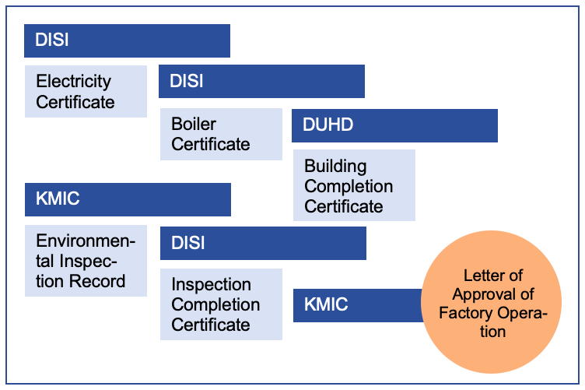

3.21.2 Process in obtaining each certificate
The following flow chart illustrates the process of obtaining each of the above mentioned five certificates needed for obtaining Letter of Approval for Factory Operation:
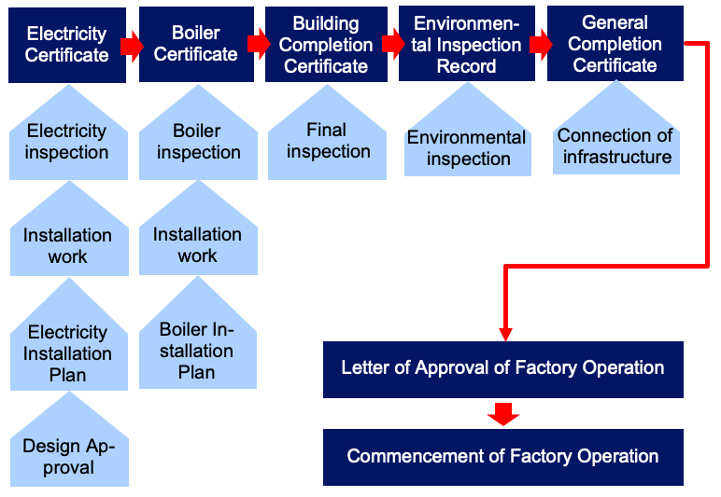

--------------------------------------------------------------------------------------------------------------------------
END OF PROCEDURE 3.21

